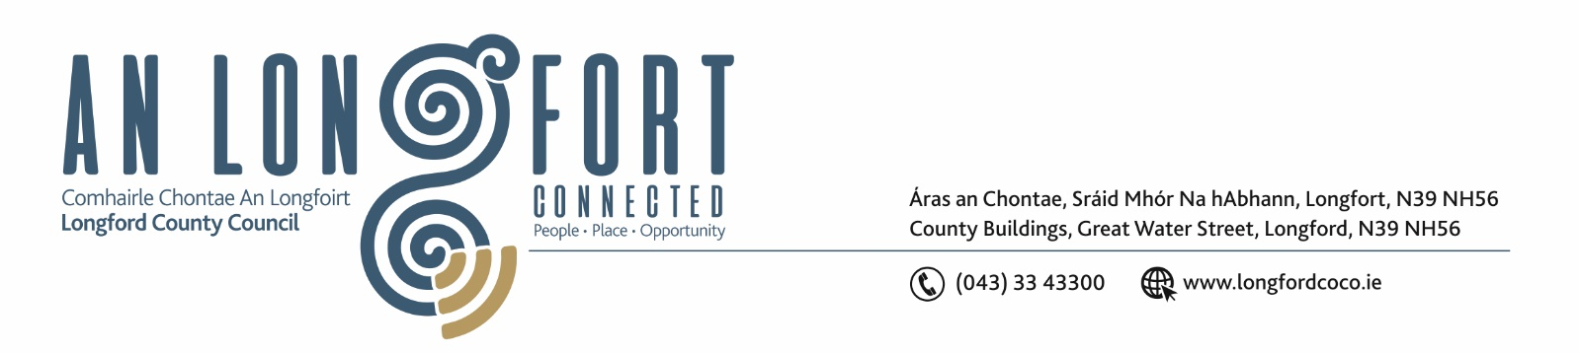

30th June 2020.

To: Each Member of the Joint Policing Committee.

Re: Meeting of the Joint Policing Committee

Dear Member,

I wish to inform you that the next meeting of the Joint Policing Committee will take place in Longford Rugby Club, Demesne, Longford on Monday, 6th July 2020 at 3.00 p.m.

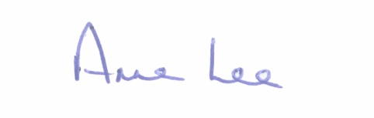
Yours sincerely,

___________________
Anne Lee,
Administrative Officer.

AGENDA

1. Confirmation of Minutes of Joint Policing Committee meeting held on the
2nd March 2020 - enclosed.

2. Matters arising.

3. Declaration of Interest by Members.
4. Apologies received.

5. Garda Report.

6. Local Authority Report.

7. Notice of Motion submitted by Councillor Garry Murtagh at March 2020 Longford County Council Meeting.
“I am calling on Longford County Council to invest in a countywide communication service, to connect and deliver messages from agencies such as Garda Emergency/Text alerts, County Council and Local Community Groups.
A free service for the people of Longford thus supporting the efforts of the Garda, Joint Policing committee (JPC) and the wider communities within the county of Longford.
Monaghan County Council are running a similar initiative (delivered by Komeer) which has proven to be very successful in providing regular communications to its members.
Komeer are happy to deliver a presentation to Longford County Council/Joint Policing Committee.”

8. Update on Longford Joint Action Plan.

9. Date of next meeting.



